USB HUB PROGRAM LOADING PROCEDURE
Connect programmer to board and switch on the board.
Press connect button, it will show up chip connected
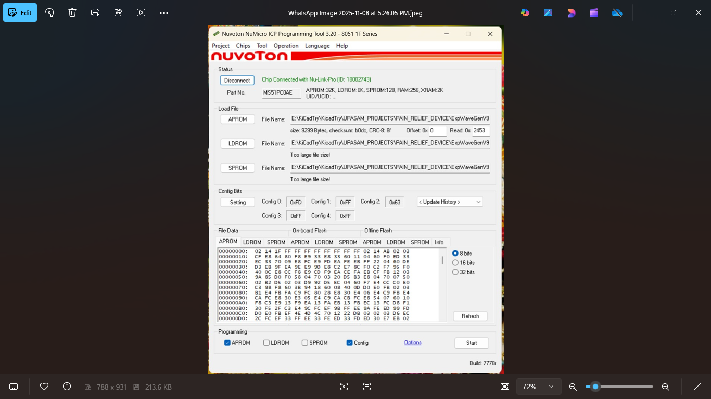
Click on APROM button and browse Hex file.
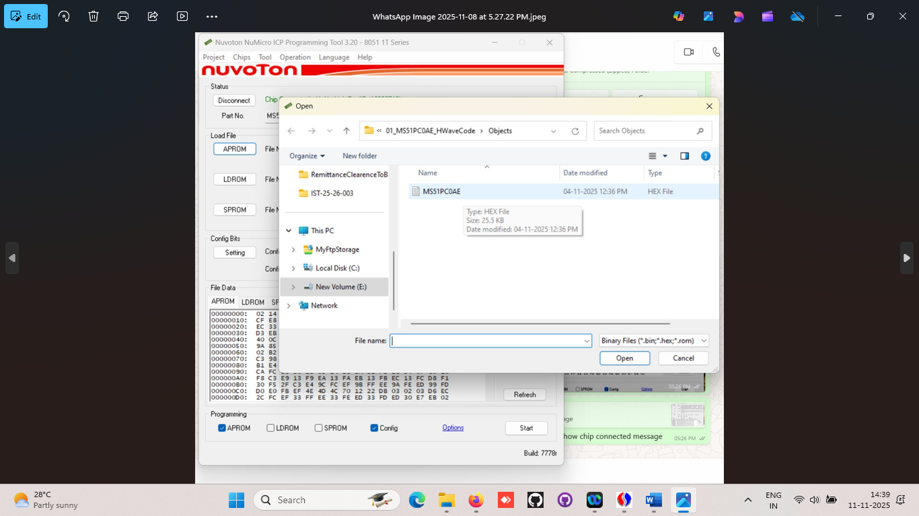

Press setting button
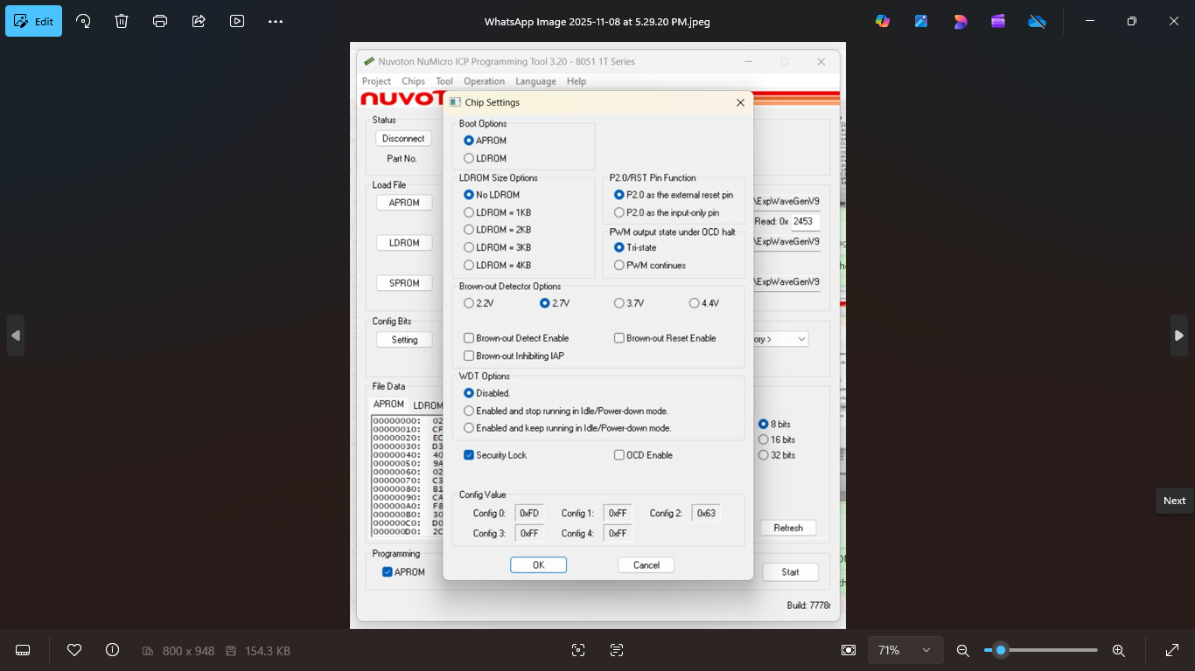

Select option button and select the option as per screen and click ok
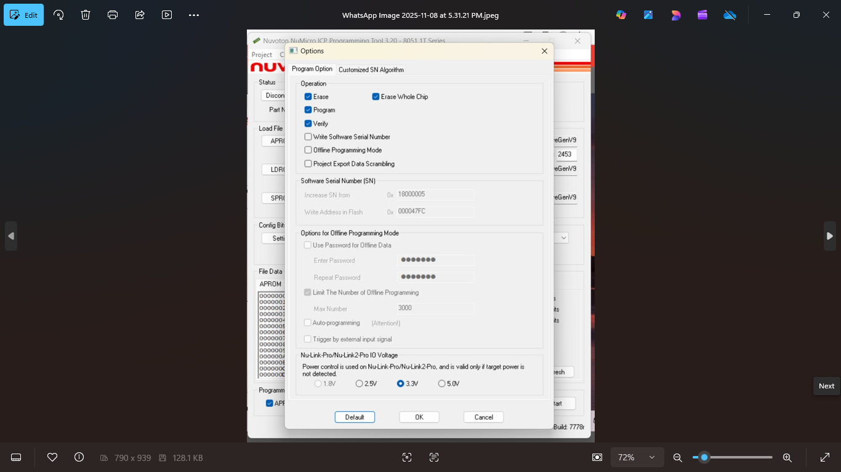

Press Start button
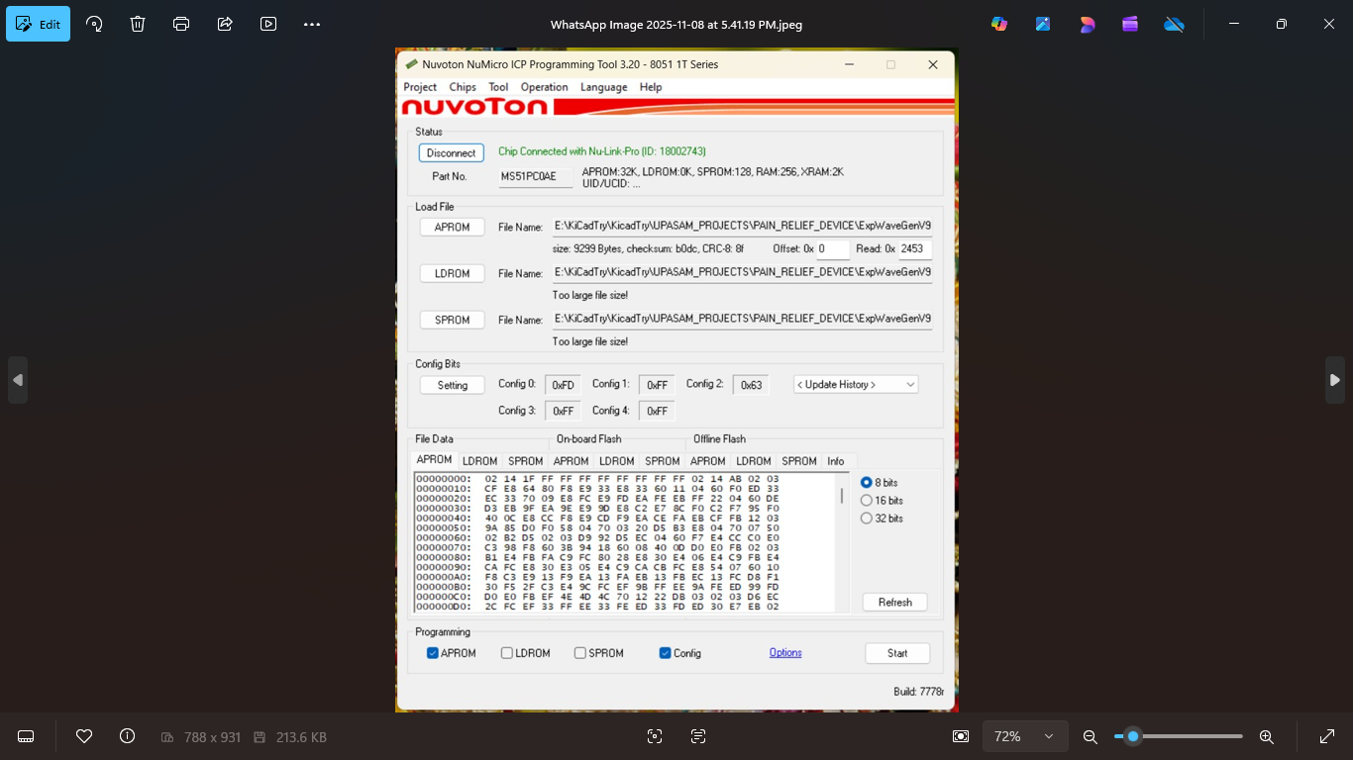

Click no for batch programming and click ok.
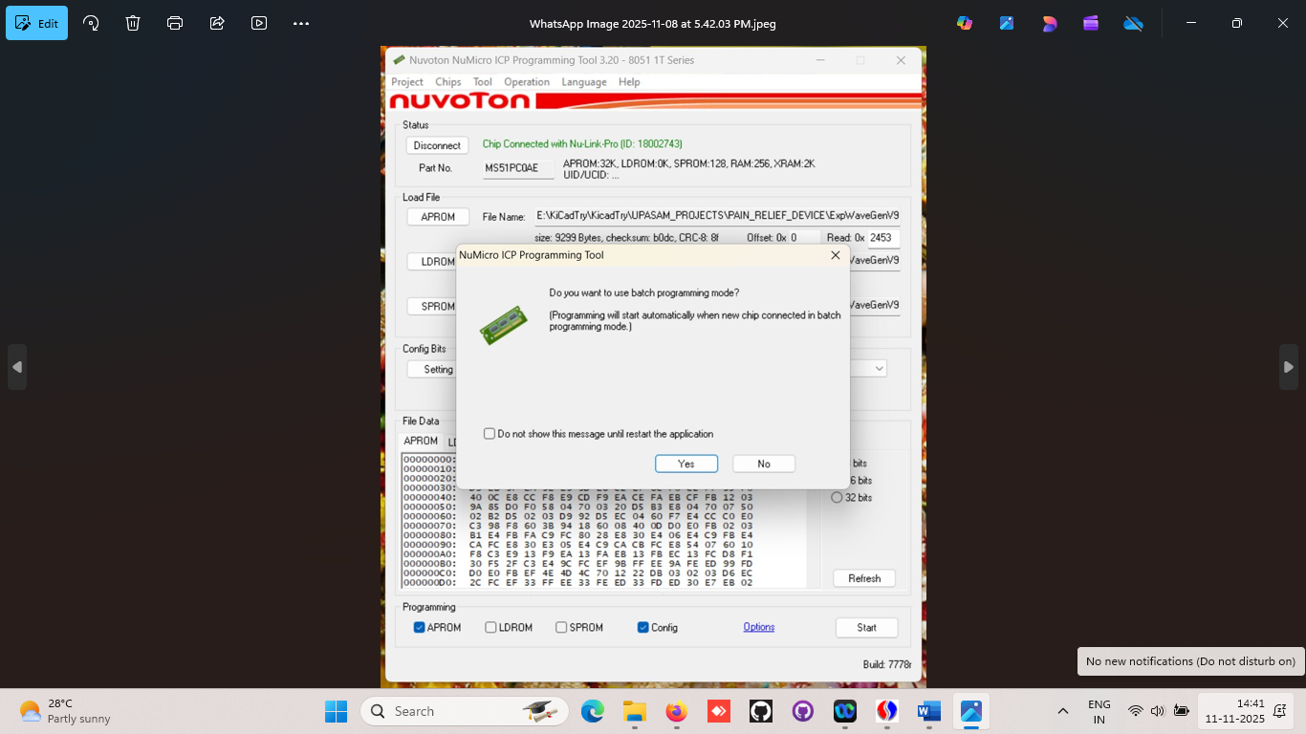

Press ok
